

Preliminary Examinations II 2010

Pre-university 3

H2 CHEMISTRY 9647 / 02

Wednesday 22 Sep 2010 2h

Additional materials:
Data Booklet

READ THESE INSTRUCTIONS FIRST

- Do not turn over this question paper until you are told to do so.

- Write your name, class and index number in the spaces provided at the top of this page.

- Write in dark blue or black pen in the spaces provided on the Question Paper.

- You may use a soft pencil for any diagrams or graphs.

- DO NOT use paper clips, highlighters, glue or correction fluid or tape.

- Answer ALL the questions.

- Give non-exact numerical answers correct to 3 significant figures, or 1 decimal place in the case of M_{r} and A_{r}, unless a different level of accuracy is specified in the question.

- The number of marks is given in brackets [ ] at the end of each question or part question.

- You are reminded of the need for clear presentation in your answers and to show all working in calculations.

- The use of a calculator is expected, where appropriate.

Paper 2
Qn No | 1 | 2 | 3 | 4 | 5 | 6 | 7 | 8 | 9 | 72
Marks Obtained |  |  |  |  |  |  |  |  |  | 72

- Three compounds, X, Y, Z, have the formula C₃H₈O.

The boiling points of the compounds are; X 10.8°C, Y 82.4°C, Z 97.4°C.

- Write structural formulas for X, Y and Z. [3]

X | Y | Z

- Account for your answer in (a) on the basis of the molecular structures and the types of intermolecular forces in each. [3]

………………………………………………………………………………………………
………………………………………………………………………………………………
………………………………………………………………………………………………
………………………………………………………………………………………………
………………………………………………………………………………………………
………………………………………………………………………………………………

- A fourth compound with the formula C₂H₄O₂, has the same molar mass as the three compounds above and boils at 117.9°C. Propose a structure for this compound and account for its higher boiling point. [2]

………………………………………………………………………………………………
………………………………………………………………………………………………
………………………………………………………………………………………………
………………………………………………………………………………………………

[Total: 8]

- Magnesium oxide, or magnesia, is a white solid mineral that occurs naturally as periclase and is a source of magnesium.

  - Using the information given below and the Data Booklet, draw an energy level diagram for the formation of magnesium oxide and use it to determine the amount of energy required for the sublimation of one mole of magnesium. [3]

 | ΔH / kJ mol^{–1}
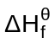 of magnesium oxide | –601
1st Electron Affinity of oxygen | –141
2nd Electron Affinity of oxygen | +790
Lattice energy of magnesium oxide | –3791

  - How would you expect the melting point of magnesium oxide to compare with that of sodium oxide? Explain your answer. [2]

………………………………………………………………………………………………
………………………………………………………………………………………………
………………………………………………………………………………………………
………………………………………………………………………………………………
  - Sketch a graph to show the variations of melting points of the oxides of Period 3 elements. [1]
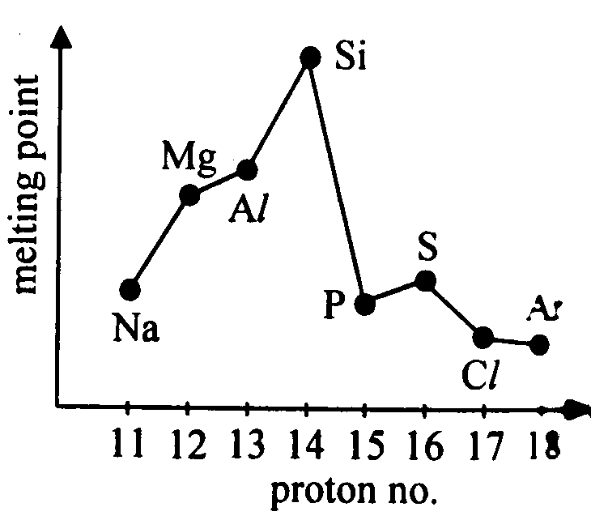
Oxides of the elements

  - Complete the following table. [3]

Compound | Sodium oxide | Aluminium oxide | Phosphorus(V) oxide
pH of the resultant solution formed when the oxide is added to water
Equations to show reaction with water, if any

[Total: 9]

- Hydrogen sulfide, H₂S, is a weak acid that can be used to precipitate metal ions from solution selectively by controlling the pH.

Acid Ionisation Constants of H₂S | K₁ | 5.7 x 10^{–8} mol dm^{–3}
Acid Ionisation Constants of H₂S | K₂ | 1.3 x 10^{–13} mol dm^{–3}

Solubility product, K_{sp}, of compounds | Bi₂S₃ | 1.6 x 10^{–72}
Solubility product, K_{sp}, of compounds | MnS | 3.0 x 10^{–11}

- Write an equation to represent the overall ionisation of H₂S to form S^{2–} and 2H⁺ and calculate the equilibrium constant for this process. [3]

- For a solution with [H₂S] = 0.10 mol dm^{–3}, with [Bi³⁺] = [Mn²⁺] = 0.0015 mol dm^{–3} and [H⁺] = 0.010 mol dm^{–3}, give the formula for the metal sulfide which precipitates first. Show your working. [3]
(If you are unable to complete (a), use the following for your calculation:
Equilibrium constant for the overall ionisation of H₂S = 7.00 x 10^{–21} mol² dm^{–6}
This is not the answer to (a))

- The pH of the solution is raised until the other metal sulfide begins to precipitate. Determine the pH of the solution at which the second metal sulfide begins to precipitate. [3]

[Total: 9]

- Iodide ion, I–(aq), reacts with peroxydisulfate ion, S₂O₈^{2–}(aq), according to the equation below.

3I–(aq) + S₂O₈^{2–}(aq) → I₃–(aq) + 2SO₄^{2–}(aq)

Equal volumes of I–(aq) and S₂O₈^{2–}(aq) are mixed at two different temperatures of 300°C and 330°C, and the variation in colour intensity was monitored over a period of time. The graphs below show the variation of the colour intensity with time.
Colour
Intensity

330°C
300°C

Time

- What is the significance of the colour intensity in this reaction? [1]

………………………………………………………………………………………………
………………………………………………………………………………………………

- State the significance of the initial slope of the graph and hence explain, with the aid of a Maxwell–Boltzmann distribution curve, the difference in the initial slopes of the two graphs. [4]

………………………………………………………………………………………………
………………………………………………………………………………………………
………………………………………………………………………………………………
………………………………………………………………………………………………
………………………………………………………………………………………………
………………………………………………………………………………………………

- A heterogeneous catalyst is usually used for this reaction.

Write equations to show how Fe²⁺(aq) can act as a suitable catalyst for the above reaction. [2]

………………………………………………………………………………………………
………………………………………………………………………………………………

[Total: 7]
- When fluorine is bubbled into water at room temperature, oxygen is evolved and a weakly-acidic solution results. The reaction below occurs:

2F₂(g) + 2H₂O(l) → 4HF(aq) + O₂(g)

- By quoting relevant data from the Data booklet, suggest why oxygen is produced with fluorine but not if chlorine is used instead of fluorine. [2]
………………………………………………………………………………………………
………………………………………………………………………………………………
………………………………………………………………………………………………

- Explain why fluorine fails to form stable oxoanions analogous to those formed by chlorine. [1]

………………………………………………………………………………………………
………………………………………………………………………………………………

- Give two reasons to explain why the resulting solution is weakly acidic. [2]

………………………………………………………………………………………………
………………………………………………………………………………………………
………………………………………………………………………………………………

- Gaseous hydrogen fluoride may be prepared in the laboratory by heating solid sodium fluoride with concentrated sulfuric acid. However when the reaction is repeated using sodium bromide, different products are formed.

Write equations to show the reaction between sodium bromide and concentrated sulfuric acid. [2]

………………………………………………………………………………………………
………………………………………………………………………………………………

[Total: 7]
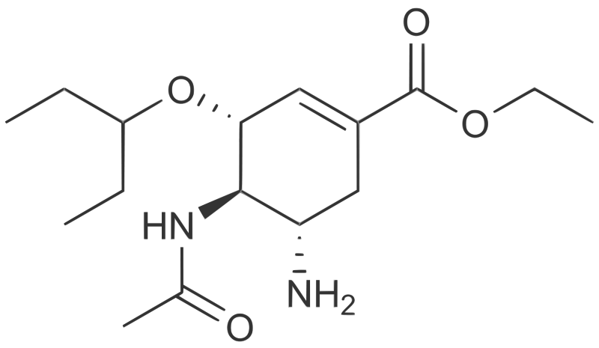
- Oseltamivir is an antiviral drug that slows the spread of influenza (flu) virus between cells in the body by stopping the virus from chemically cutting ties with its host cell. The drug is sold under the trade name “Tamiflu” and has been used to treat and prevent Influenzavirus A and
Influenzavirus B infection in over 50 million people since 1999.

Draw the structure of the product(s) formed when Oseltamivir reacts with the following reagents. [6]

- HCl(aq) at room temperature

- Cold dilute alkaline KMnO₄(aq)

- Hot acidified Na₂Cr₂O₇(aq)

[Total: 6]
- P reacts with hydrogen cyanide to form two stereoisomers.

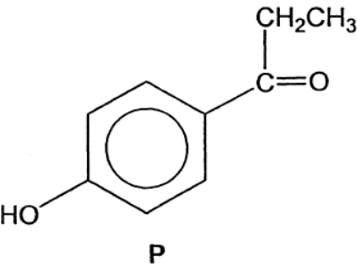

- Describe the mechanism for the reaction between P and hydrogen cyanide. [3]

- Using your answer in (a), explain briefly why a pair of stereoisomers is formed. [2]

………………………………………………………………………………………………
………………………………………………………………………………………………
………………………………………………………………………………………………

- Suggest how the pair of stereoisomers can be distinguished. [1]

………………………………………………………………………………………………
………………………………………………………………………………………………
………………………………………………………………………………………………

[Total: 6]
- A student was asked to prepare phenyl benzoate, C₆H₅CO₂C₆H₅, using benzene as the starting material for both the aromatic rings. He suggested the following synthetic scheme.

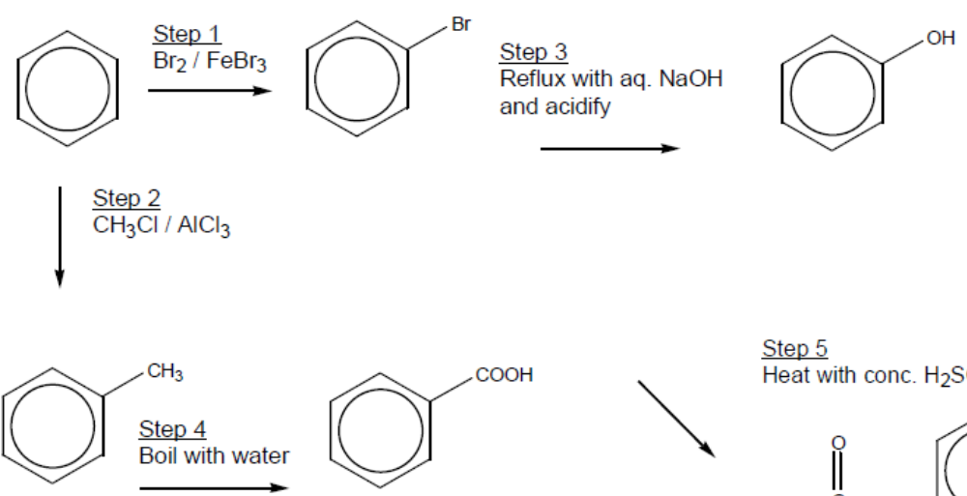

Step 5 phenol
X C₆H₅CO₂C₆H₅

Steps 3 and 4 are unsatisfactory in an organic synthesis.

- Explain why reaction in step 3 does not take place to an appreciable extent. [2]

………………………………………………………………………………………………
………………………………………………………………………………………………
………………………………………………………………………………………………
………………………………………………………………………………………………

- Give the correct reagent(s) and condition(s) for step 4. [1]

………………………………………………………………………………………………

- Complete the synthetic scheme by suggesting the reagent(s) and condition(s) for Step 5 and hence identify X. [2]

………………………………………………………………………………………………

- Describe the reaction mechanism involved in Step 2. [3]

[Total: 8 marks]

- You are to plan an investigation into the thermal decomposition of caesium nitrate, CsNO₃.

You may make use of some or all of the following data when planning your investigation.

Group I element | Cation | Ionic Radius / nm
Lithium | Li⁺ | 0.060
Sodium | Na⁺ | 0.095
Potassium | K⁺ | 0.133
Rubidium | Rb⁺ | 0.148
Caesium | Cs⁺ | 0.176
d
Equations for the thermal decomposition of lithium nitrate and sodium nitrate are given below.
4LiNO₃(s) → 2Li₂O(s) + 4NO₂(g) + O₂(g)
2NaNO₃(s) → 2NaNO₂(s) + O₂(g)

d
Nitrogen dioxide gas, NO₂ | Oxygen gas, O₂
Brown in colour | Colourless
Soluble in water | Almost insoluble in water
Poisonous | Powerful oxidant
1 mol of any gas occupies a volume of approximately 24 dm³ at room temperature and atmospheric pressure.

A_{r}: Cs, 133; N, 14.0; O, 16.0

- Predict which of the equations below will represent the thermal decomposition of caesium nitrate. Place a tick against the equation of your choice.

4CsNO₃(s) → 2Cs₂O(s) + 4NO₂(g) + O₂(g)
2CsNO₃(s) → 2CsNO₂(s) + O₂(g)

Use data provided on the previous page to explain your prediction. [1]

………………………………………………………………………………………………

- You are to plan an experiment to confirm or reject your prediction in (a).

- Suggest a suitable mass of caesium nitrate to be used. State your reasons for choosing this mass by explaining why the use of either a very large or a very small mass of caesium nitrate could lead to an inaccurate result. [2]

…………………………………………………………………………………………
…………………………………………………………………………………………
…………………………………………………………………………………………
…………………………………………………………………………………………

- Describe the apparatus you would use, and outline, in a series of numbered steps, the method to be used in the experiment, indicating clearly how you will know when decomposition is complete. [3]

You may draw a diagram, if you wish, to help to illustrate your description. You need not explain how the apparatus is assembled.

…………………………………………………………………………………………
…………………………………………………………………………………………
…………………………………………………………………………………………
…………………………………………………………………………………………
…………………………………………………………………………………………

- Show how the measurements will be recorded in an appropriate manner. [1]

- Show how you would use the measurements in a calculation to confirm or reject your prediction. [2]

- State one important feature in the method you suggested and explain its importance in ensuring accurate results. [1]

………………………………………………………………………………………………
………………………………………………………………………………………………

- Identify a risk present in the method you have described. [1]

………………………………………………………………………………………………

- Describe how you would minimise the risk stated in (d). [1]

………………………………………………………………………………………………

[Total: 12]
-END OF PAPER-

